**Task # 01:** Design the following web page using heading H1 to H6.

**SOLUTION**:

 <p>there are six levels of heading in HTML. The lower the number the larger the header will be. the h1 is the larger

        header and h6 is the smallest</p>

    <h1>HEADING NO 1</h1>

    <h2>HEADING NO 2</h2>

    <h3>HEADING NO 3</h3>

    <h4>HEADING NO 4</h4>

    <h5>HEADING NO 5</h5>

    <h6>HEADING NO 6</h6>

**OUTPUT:**

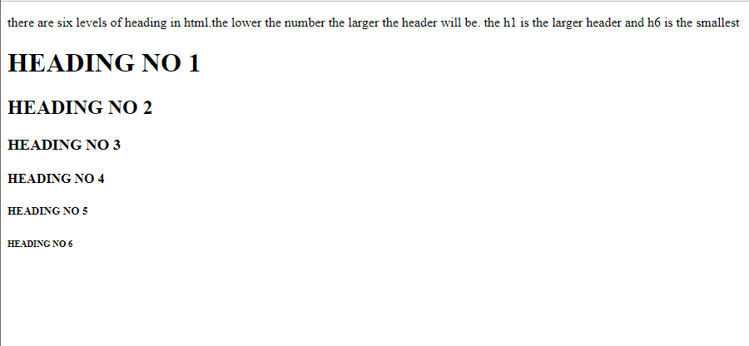

**Task # 02:** Using Center tag, design the following web page.

**SOLUTION:**

<body>

   <h3 style="text-align: center;">The Centre Tag</h3>

   <p style="text-align: center;">by using this tag our sentence is now Centre</p>

</body>

**OUTPUT:**

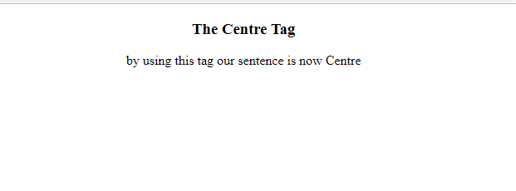

**Task # 03:** Create a hyperlink and navigate to it from your web page.

**SOLUTION:**

  <h4 style="text-align: center; color: red;">bahira university Karachi campus</h4>

    <p style="text-align: center;"> to view the site, kindly click: <a href="https://www.bahria.edu.pk/" target="_blank">BUKC</a></p>

**OUTPUT:** 

**Task # 04:** Using font color, design the following web page.

**SOLUTION:**

<div style="text-align: center;">

    <h1>colors</h1>

  <h3 style="color: red;">Red</h3>

  <h3 style="color: green;">green </h3>

  <h3 style="color: blue;">blue</h3>

  <h3 style="color: pink;">pink</h3>

  <h3 style="color: yellow;">yellow</h3>

  <h3 style="color: gray;">gray</h3>

</div>

**OUTPUT:**

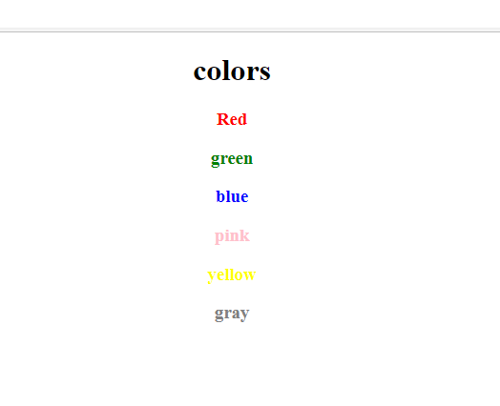

**Task # 05:** Add an image to the webpage.

**SOLUTION:**

<div style="text-align: center;">

<h2>Image</h2>

<img src="horse.jpg" alt="tree-img" style="margin-left: 470px; margin-right: 470px; width: 350px;">

<figcaption>image of a horse</figcaption>

</div>

**OUTPUT:** 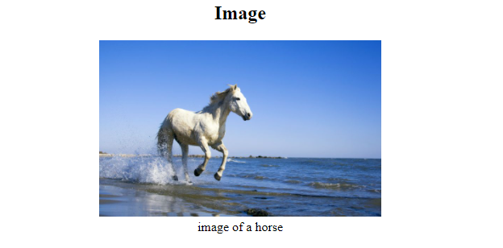

**Task # 06:** Use the align attribute with <p> tag, design the following web page:

**SOLUTION:**

<P style="text-align: right;">Align text to the Right</P>

<P style="text-align: center;">Align text to the CENTRE</P>

<P style="text-align: left;">Align text to the LEFT</P>

**OUTPUT:** 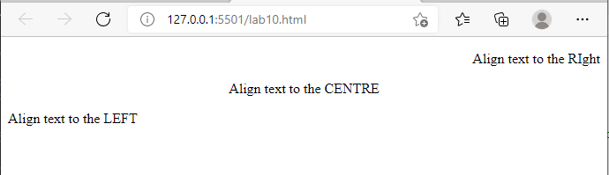

**Task # 07:** Create a page having three types of lists. Ordered list, unordered list and Definition list.

**SOLUTION:**

<h3>unordered list</h3>

<ul style="">

    <li>tea</li>

    <li>coffee</li>

    <li>milk</li>

</ul>

<h3>ordered list</h3>

<ol>

    <li>burger</li>

    <li>pizza</li>

    <li>biryani</li>

</ol>

<h3>Definition list</h3>

<dl>

   <dt>tea</dt>

    <dd>this is tea</dd>

    <dt>coffee</dt>

    <dd>this is coffee</dd>

    <dt>milk</dt>

    <dd>this is milk</dd>

</dl>

**OUTPUT:**

